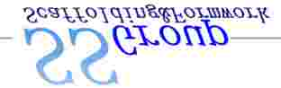

SS Products For Your Construction Need

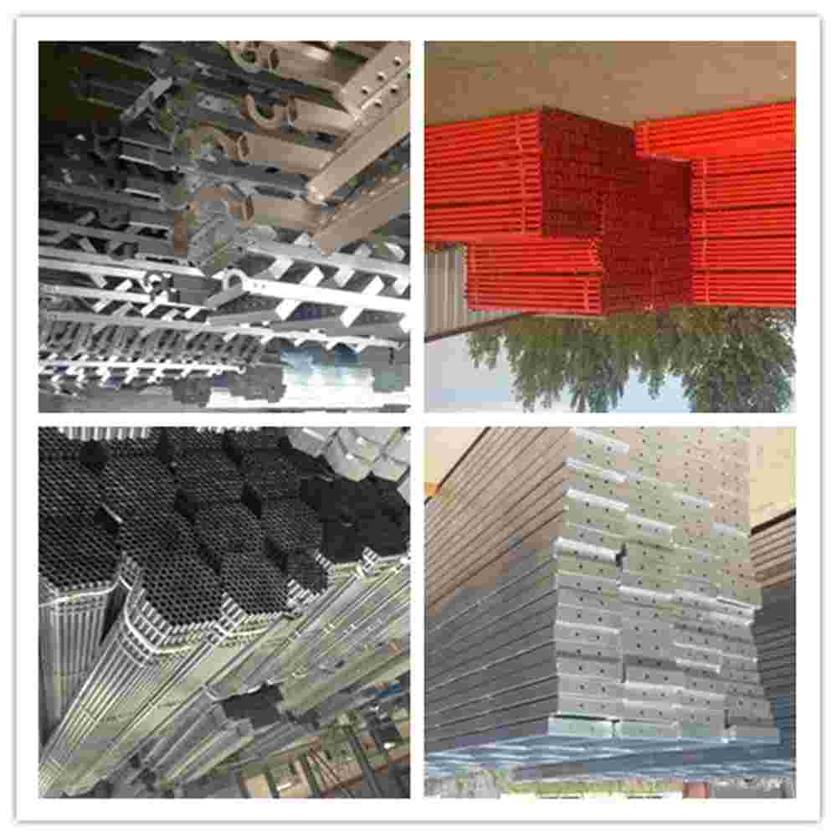

# Content

**Steel Pipe & Pipe Fittings**



* Round Pipe
* Square & Rectangular Hollow Section
* Angle Plate
* Elbow
* Flange

**Scaffolding & Shoring Products**

* H-Frame Scaffolding
* Ring Lock Scaffolding
* Cup Lock Scaffolding
* Steel Prop (Shoring)
* Scaffolding GI Pipe
* Scaffolding Accessories

**Formwork Product**

* Metal Form
* Aluminum Form
* Plywood
* Formwork Accessories



**SS Trusted Name In China**

**Web:** [www.tjtsxgroupe.com](http://www.tjtsxgroupe.com/) **Tel:** +86 13352035283 **Fax:** +86 22 83973368 **Email:** <anna@shishenggroup.com>

# Steel Pipe & Pipe Fittings

**Size & Dimension**

|  |
| --- |
| **Standard:** BS 1387, JIS G3452, API 5L Gr.B  **Outer Diameter :** 15mm – 2825mm  **Wall Thickness:** 1.5mm – 80mm  **Material:** Carbon Steel–  Q 195, Q215, Q235, Q345, X42, X80, J55, etc |
| **Furnishing:** Bared , Black Painted, Oiled, etc | | |

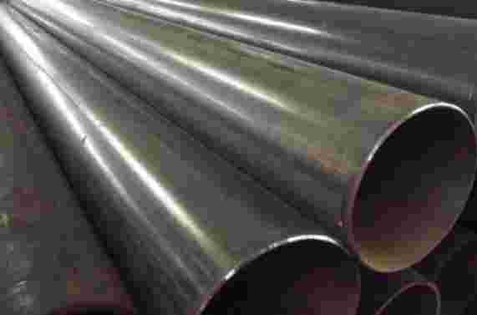

**Size & Dimension**

**Standard:** BS 1387, JIS G3452, API 5L Gr.B

**Outer Diameter:** 19mm – 609mm

**Wall Thickness:** 0.25mm – 15.75mm

**Material:** Carbon Steel–

Q 195, Q215, Q235, Q345, X42, X80, J55, etc

**Furnishing:** Bared, With Oiled, Galvanized, etc

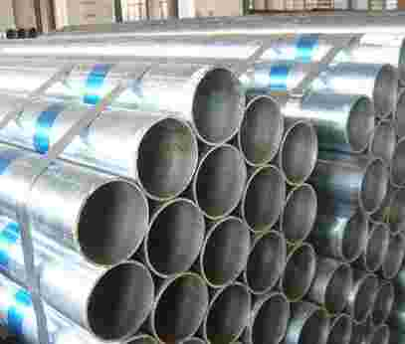

**Size & Dimension**

**Standard:** API 5L PSL1, API 5L PSL2 ASTM A252

**Outer Diameter:** 219 – 2540mm

**Wall Thickness:** 1.65--26.97mm

**Material:** GR.B, X42, X46, X52, X56, X60, X65, X70, etc

**Furnishing:** Bared, Black Painted, With Oiled, etc

Corrosion Resistant Coating + Cap

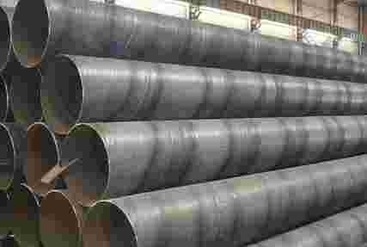

**Size & Dimension**

**Standard:** BS EN 545/ BS EN 598/ ISO2531

**Size:** DN40 - DN2600

**Wall Thickness:** 4.8 – 25mm

**Material:** Ductile Iron, Cast Iron, etc

**Brand:** Saint Gobain, Chinese Brand

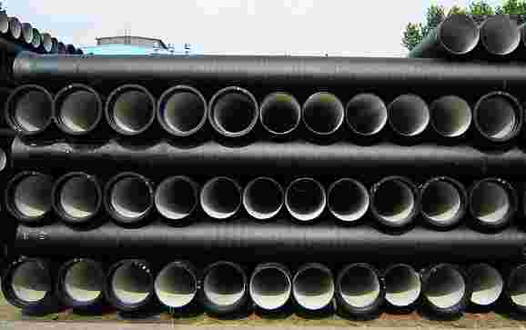

**SS Trusted Name In China**



**Web:** [www.tjtsxgroupe.com](http://www.tjtsxgroupe.com/) **Tel:** +86 13352035283 **Fax:** +86 22 83973368 **Email:** <anna@shishenggroup.com>

:

**Size & Dimension**

**Standard:** ASTM A500 Gr. A/B, EN10210/10219

**Size:**  10*10 – 1000*1000mm

**Wall Thickness:** 1.50 -14.00mm

**Material:** Carbon Steel–

Q 195, Q215, Q235, Q345, X42, X80, J55, etc

**Furnishing:** Bared, With Oiled, Galvanized, etc

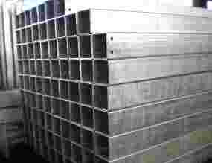

**Size & Dimension**

**Standard:** ASTM A500 Gr. A/B, EN10210/10219

**Size:** 10*10 – 1000*1000mm

**Wall Thickness:** 1.50 -14.00mm

**Material:** Carbon Steel–

Q 195, Q215, Q235, Q345, X42, X80, J55, etc

**Furnishing:** Bared, With Oiled, Galvanized, etc

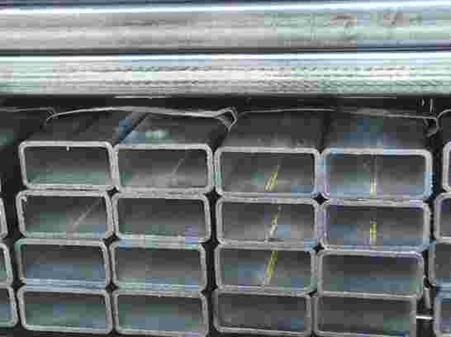

**Size & Dimension**

**Thickness:** 2 – 7 mm

**Length:**  3 – 19 Meter

**Edge Length:** 20 – 90 mm

**Materials:**  Q 235, Q 345

**Standard:** JISG1211—1215、BS1837

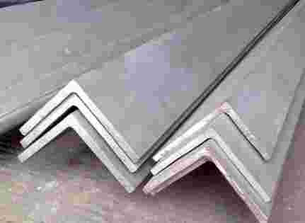

**SS Trusted Name In China**

**Web:** [www.tjtsxgroupe.com](http://www.tjtsxgroupe.com/) **Tel:** +86 13352035283 **Fax:** +86 22 83973368 **Email:** <anna@shishenggroup.com>



**Size & Dimension:**

**Diameter:** 6.5 – 40 mm

**Length:**  6 – 12 meter

**Materials:** Q 235

**Standard:**  JISG3191—66（94）, BS4449—97

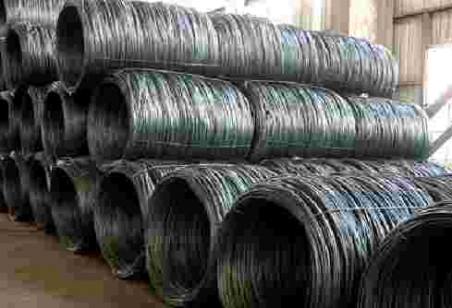

**Size & Dimension:**

**Diameter:** 6 – 50 mm

**Length :**  3.5 – 12 meters

**Materials:** 20MnSi、20MnV、25MnSi、BS20MnSi, Q 235

**Standard:** JISG3191—66（94）, BS4449—97

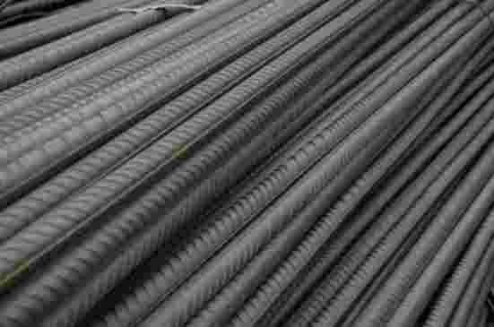

**Size & Dimension:**

**Diameter:** 6 – 50 mm

**Length :**  3.5 – 12 meters

**Materials:** 20MnSi、20MnV、25MnSi、BS20MnSi, Q 235

**Standard :** JISG3191—66（94）, BS4449—97

**Size & Dimension:**

**Height:**  5 – 40 cm

**Length:**  5 – 15 Meter

**Materials:** Q 235, Q345

**Standard:**  ISO 9001 --- 2000

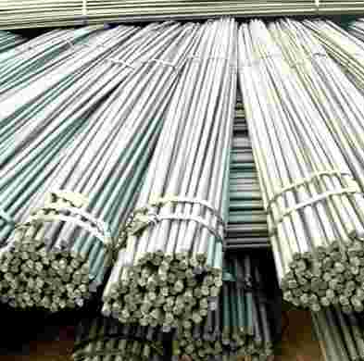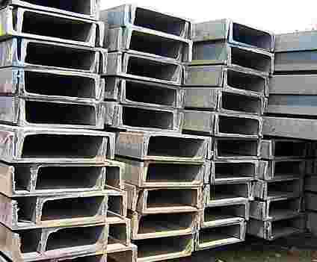

**Web:** [www.tjtsxgroupe.com](http://www.tjtsxgroupe.com/) **Tel:** +86 13352035283 **Fax:** +86 22 83973368 **Email:** <anna@shishenggroup.com>

:



**Size & Dimension**

**HW :** 100*100 – 400*400 mm

**HM :** 150*100 – 600*300 mm

**HN:**  150*75 – 900*300 mm

**Materials:** Q 235, Q345

**SS Trusted Name In China**

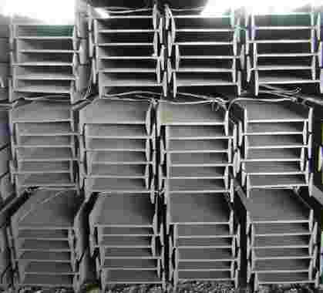

# Pipe Fittings



**Elbow**

**Long & Short Radius**

45, 90 & 180 Degrees Available

**Standard:** GB /ASTM / ASME / DIN / JIS  
ASTM B 16.9 / B 16.28, JIS B 2311/2312/2313

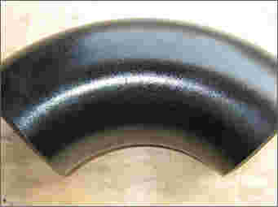

**Tee**

**Equal Tee & Reducing Tee**

**Standard:** GB /ASTM / ASME / DIN / JIS  
ASTM B 16.9 / B 16.28, JIS B 2311/2312/2313

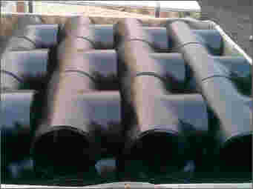

**Cap**

**Standard:** GB /ASTM / ASME / DIN / JIS  
ASTM B 16.9 / B 16.28, JIS B 2311/2312/2313

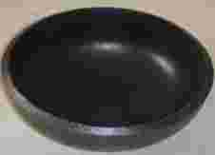

**Reducers**

**Concentric & Eccentric Reducers**

**Standard:** GB /ASTM / ASME / DIN / JIS  
ASTM B 16.9 / B 16.28, JIS B 2311/2312/2313



**SS Trusted Name In China**

**Web:** [www.tjtsxgroupe.com](http://www.tjtsxgroupe.com/) **Tel:** +86 13352035283 **Fax:** +86 22 83973368 **Email:** <anna@shishenggroup.com>

:

**TSX Trusted Name In China**

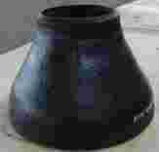

# Flange



**Slip – On Flange**

**Threaded Flange**

**Raised Faced Flange**

**Plate Flange**

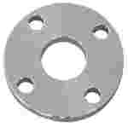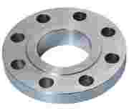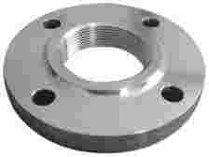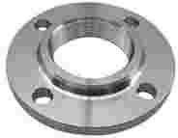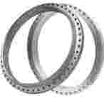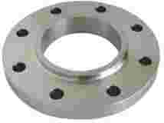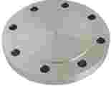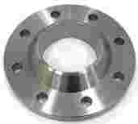

**Blind Flange**

**Lap Joint Flange**

**Socket Welding Flange**

**Welding Neck Flange**

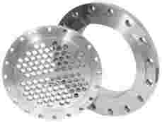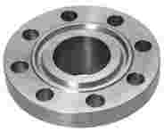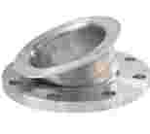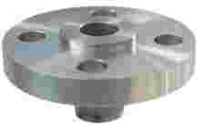

**Slip – On Butt**

**Welding Flange**

**Pipe Plate**

**High Pressure Flange**

**Ring Type Joint Flange**

|  |  |
| --- | --- |
| **Standard** | ANSI B 16.9, ANSI B 16.11 JIS B2311, B2312, B2316 |
| **Material** | Carbon Steel, Stainless Steel, etc |
| **Type** | BW / SW / THD / NPT / NPTM / NPTF |
| **DN** | DN 15 – DN 2000 |



**SS Trusted Name In China**

**Web:** [www.tjtsxgroupe.com](http://www.tjtsxgroupe.com/) **Tel:** +86 13352035283 **Fax:** +86 22 83973368 **Email:** <anna@shishenggroup.com>

:

# Scaffolding & Shoring Products



## H-Frame Scaffolding

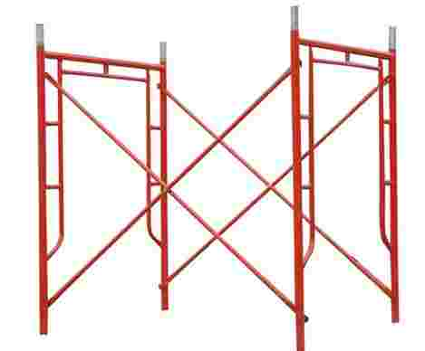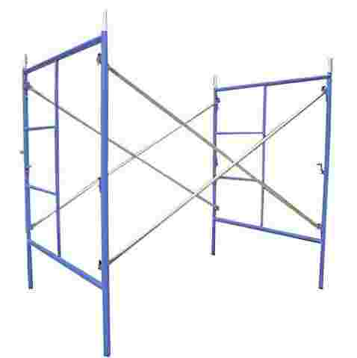

* **Technical Specifications**

|  |  |
| --- | --- |
| **Material** | Q195/215/235/345, etc |
| **Standard** | EN39/74, BS1139 |
| **Surface** | Galvanized, Painted |
| **Size** | Main Frame: 1700*1219mm  Cross Brace: 1829*1219*2198mm  Joint Pin: 36*2.0*225mm |

**Components**

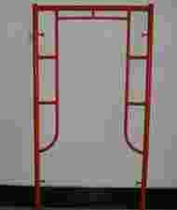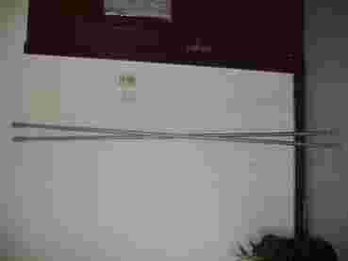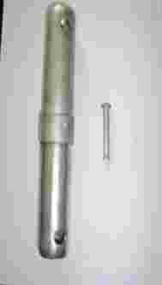

**Web:** [www.tjtsxgroupe.com](http://www.tjtsxgroupe.com/) **Tel:** +86 13352035283 **Fax:** +86 22 83973368 **Email:** <anna@shishenggroup.com>

:



**SS Trusted Name In China**

## Ring Lock Scaffolding

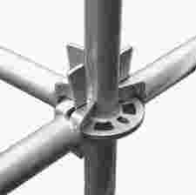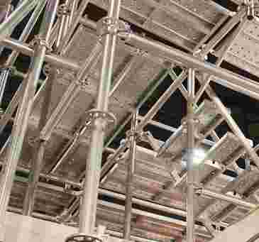

* **Technical Specifications**

|  |  |
| --- | --- |
| **Material** | Q195/215/235/345, etc |
| **Standard** | EN39/74, BS1139 |
| **Surface** | Galvanized, Painted |
| **Size** | Steel pipe diameter is 48.3mm  Thickness: 2.75/3.0/3.2/3.25/4.0mm  Length: 0.5/1.0/1.5/2.0/2.5/3.0m |

**Components**

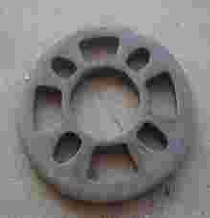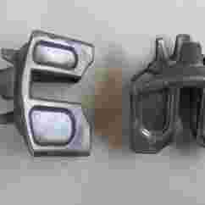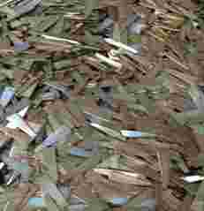

**SS Trusted Name In China**

**Web:** [www.tjtsxgroupe.com](http://www.tjtsxgroupe.com/) **Tel:** +86 13352035283 **Fax:** +86 22 83973368 **Email:** <anna@shishenggroup.com>

:

## Cup Lock Scaffolding

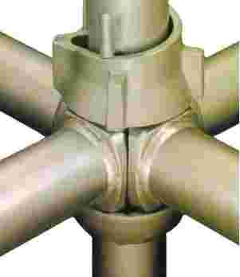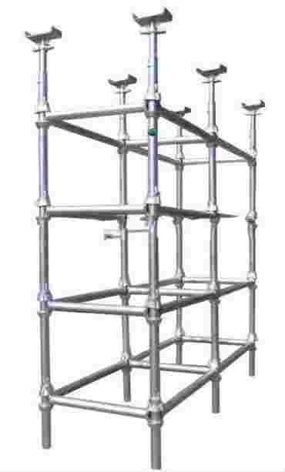

* **Technical Specifications**

|  |  |
| --- | --- |
| **Material** | Q235/345 |
| **Standard** | EN39/74, BS1139 |
| **Surface** | Galvanized, Painted |
| **Size** | Steel pipe diameter is 48.3mm  Thickness: 2.75/3.0/3.2/3.25/4.0mm  Length: 0.5/1.0/1.5/2.0/2.5/3.0m |

**Components**

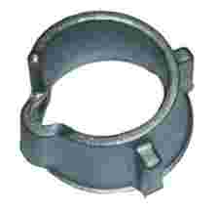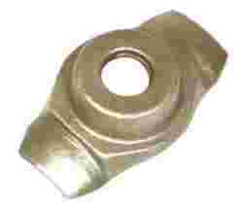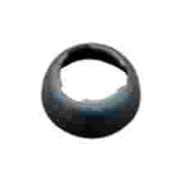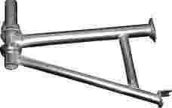

**SS Trusted Name In China**

**Web:** [www.tjtsxgroupe.com](http://www.tjtsxgroupe.com/) **Tel:** +86 13352035283 **Fax:** +86 22 83973368 **Email:** <anna@shishenggroup.com>



# Steel Prop

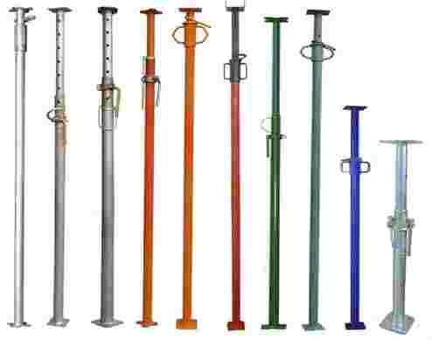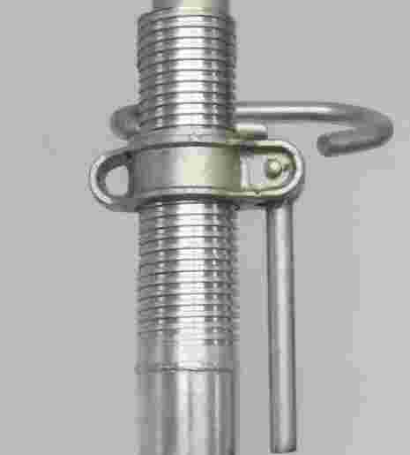

|  |  |  |  |
| --- | --- | --- | --- |
| **Size** | **Closed** | **Open** | **Finish** |
| 0 | 1.6m | 2.9m | Galvanized/Painted |
| 1 | 1.7m | 3.0m | Galvanized/Painted |
| 2 | 1.8m | 3.2m | Galvanized/Painted |
| 3 | 2.0m | 3.5m | Galvanized/Painted |
| 4 | 2.0m | 3.6m | Galvanized/Painted |
| 5 | 2.2m | 4.0m | Galvanized/Painted |
| 6 | 2.5m | 4.5m | Galvanized/Painted |

# Accessories

**SS Trusted Name In China**

**Web:** [www.tjtsxgroupe.com](http://www.tjtsxgroupe.com/) **Tel:** +86 13352035283 **Fax:** +86 22 83973368 **Email:** <anna@shishenggroup.com>

:

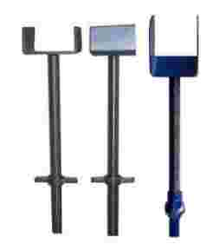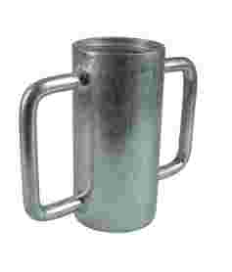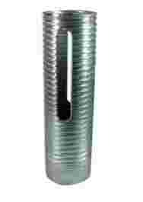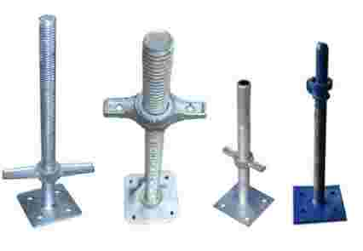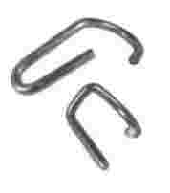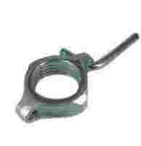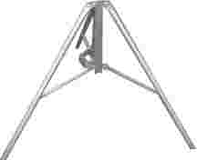

# Scaffolding GI Pipe/Tube



**Size & Dimension:**

**Standard:**  JIS G3444 - Grade STK 500

**O.D :**  48.3mm - 48.6mm

**W.T:**  2.00/ 2.40 / 3.20/4.00mm

**Length:**  1.50 – 6.00 Meter

**Material:** Carbon Steel – Q235, Q345

**Surface:** Hot Dip Galvanized

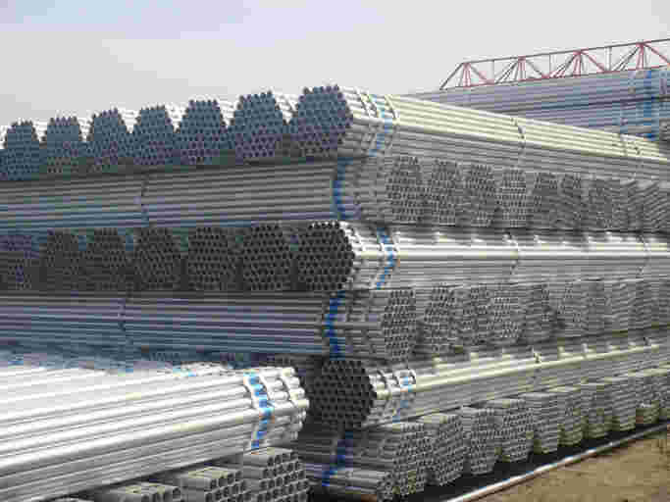

|  |  |
| --- | --- |
| **Product Description** | **Size& Dimension(mm)** |
| Galv.(1.0m length) | 210/240/250/420/480* 45 |
| Galv.(1.5m length) | 210/240/250/420/480* 45 |
| Galv.(2.0m length) | 210/240/250/420/480* 45 |
| Galv.(3.0m length) | 210/240/250/420/480* 45 |
| Galv.(4.0m length) | 210/240/250/420/480* 45 |

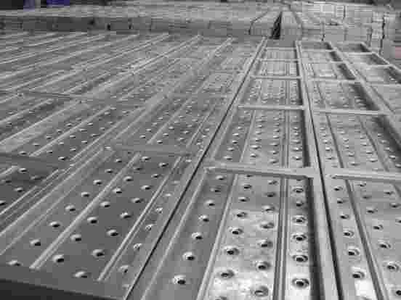

*(Various Species could be manufactured as your requirement)*

**Web:** [www.tjtsxgroupe.com](http://www.tjtsxgroupe.com/) **Tel:** +86 13352035283 **Fax:** +86 22 83973368 **Email:** <anna@shishenggroup.com>



**SS Trusted Name In China**

# Scaffolding Accessories



|  |  |  |  |  |
| --- | --- | --- | --- | --- |
| **Picture** | **Item** | **Description (mm)** | **Weight** | **Surface** |
|  | Double/Right Angle Coupler | 48.3mm*48.3mm*3.20/4.00mm | 1130g | Zinc-galvanized |
|  | Swivel Coupler | 48.3mm*48.3mm*3.20/4.00mm | 1020g | Zinc-galvanized |
|  | Sleeve Coupler | 48.3mm*48.3mm*3.20/4.00mm | 1000g | Zinc-galvanized |
|  | Joint Pin | 48.3mm*48.3mm*3.20/4.00mm | 720g | Zinc-galvanized |
|  | Fixed Coupler | 48.3mm*48.3mm*3.20 | 620g | Zinc-galvanized |
|  | Base  Plate | Plated: 152*152*5mm  Tube:38*2.5*50mm |  | Electroplated |

**Web:** [www.tjtsxgroupe.com](http://www.tjtsxgroupe.com/) **Tel:** +86 13352035283 **Fax:** +86 22 83973368 **Email:** <anna@shishenggroup.com>

:



**SS Trusted Name In China**

# Formwork -- Flat Form

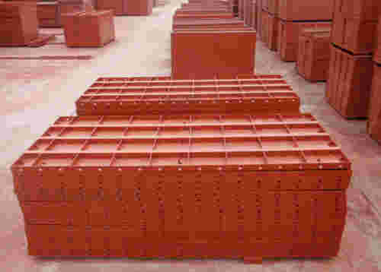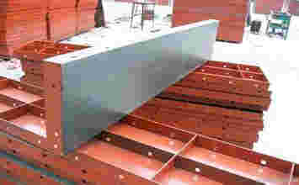

|  |  |
| --- | --- |
| **CODE** | **DIMENSION (MM)** |
| F2018 | 200 * 1800 *55 |
| F2015 | 200 * 1500 * 55 |
| F2012 | 200 * 1200 * 55 |
| F2009 | 200 *900 * 55 |
| F2007 | 200 * 750 * 55 |
| F2006 | 200 * 600 * 55 |

|  |  |
| --- | --- |
| **CODE** | **DIMENSION(MM)** |
| F3018 | 300*1800*55 |
| F3015 | 300*1500*55 |
| F3012 | 300*1200*55 |
| F3009 | 300*900*55 |
| F3007 | 300*750*55 |
| F3006 | 300*600*55 |

|  |  |
| --- | --- |
| **CODE** | **DIMENSION (MM)** |
| F1518 | 150 X 1800 X 55 |
| F1515 | 150 X 1500 X 55 |
| F1512 | 150 X 1200 X 55 |
| F1509 | 150 X 900 X 55 |
| F1507 | 150 X 750 X 55 |
| F1506 | 150  600 X 55 |

|  |  |
| --- | --- |
| **CODE** | **DIMENSION (MM)** |
| F1218 | 125*1800*55 |
| F1215 | 125*1500*55 |
| F1212 | 125*1200*55 |
| F1209 | 125*900*55 |
| F1207 | 125*750*55 |
| F1206 | 125*600*55 |

|  |  |
| --- | --- |
| **CODE** | **DIMENSION (MM)** |
| **F1018** | **100*1800*55** |
| F1015 | 100*1500*55 |
| F1012 | 100*1200*55 |
| F1007 | 100*750*55 |
| F1006 | 100*600*55 |

**Inner Corner Form**

SS-Trusted Name in CHINA

**Web:** [www.tjtsxgroupe.com](http://www.tjtsxgroupe.com/) **Tel:** +86 13352035283 **Fax:** +86 22 83973368 **Email:** <anna@shishenggroup.com>

:



**Web:** [www.tsxgroupe.com](http://www.tsxgroupe.com/) **Tel:** +86 68571101 **Fax:** +86 68571102 **Email:** [mike@tsxgroupe.com](mailto:sales@tsxgroupe.com)

:

**Web:** [www.tsxgroupe.com](http://www.tsxgroupe.com/) **Tel:** +86 68571101 **Fax:** +86 68571102 **Email:** [mike@tsxgroupe.com](mailto:sales@tsxgroupe.com)

:



|  |  |
| --- | --- |
| **Code** | **Dimension (mm)** |
| CF0518 | 100 X 1800 X 150 |
| CF0515 | 100 X 1500 X 150 |
| CF0512 | 100 X 1200 X 150 |
| CF0509 | 100 X 900 X 150 |
| CF0507 | 100 X 750 X 150 |
| CF0506 | 100 X 600 X 150 |

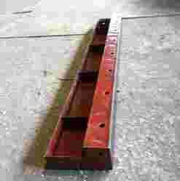

|  |  |
| --- | --- |
| CF5518 | 150 X 1800 X 150 |
| CF5515 | 150 X 1500 X 150 |
| CF5512 | 150 X 1200 X 150 |
| CF5509 | 150 X 900 X 150 |
| CF5507 | 150 X 750 X 150 |
| CF5506 | 150 X 600 X 150 |

**Corner Angle Form**

|  |  |
| --- | --- |
| **Code** | **Dimension (mm)** |
| CA0015 | 50 X 1500 X 50 |
| CA0012 | 50 X 1200 X 50 |
| CA0009 | 50 X 900 X 50 |
| CA0007 | 50 X 750 X 50 |
| CA0006 | 50 X 600 X 50 |

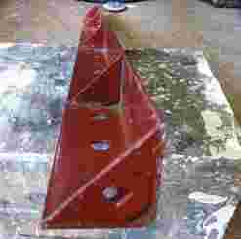

**L – Shape Forms**

SS-Trusted Name in CHINA

**Web:** [www.tjtsxgroupe.com](http://www.tjtsxgroupe.com/) **Tel:** +86 13352035283 **Fax:** +86 22 83973368 **Email:** <anna@shishenggroup.com>

:



|  |  |
| --- | --- |
| **Code** | **Dimension (mm)** |
| L1015A | 100 X 300 X 150 |
| L1015B | 100 X 350 X 150 |
| L1015C | 100 X 400 X 150 |
| L1015D | 100 X 450 X 150 |
| L1015E | 100 X 500 X 150 |
| L1515A | 150 X 300 X 150 |
| L1515B | 150 X 350 X 150 |
| L1515C | 150 X 400 X 150 |
| L1515D | 150 X 450 X 150 |
| L1515E | 150 X 500 X 150 |

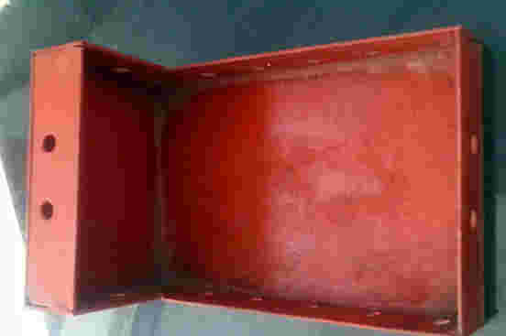

|  |  |
| --- | --- |
| **Code** | **Dimension (mm)** |
| S1515A | 150 X 300 X 150 |
| S1515B | 150 X 350 X 150 |
| S1515C | 150 X 400 X 150 |
| S1515D | 150 X 450 X 150 |
| S1515AA | 100 X 325 X 150 |
| S1515BB | 100 X 375 X 150 |
| S1515CC | 100 X 425 X 150 |
| S1515DD | 100 X 475 X 150 |

**Square Corner Form**

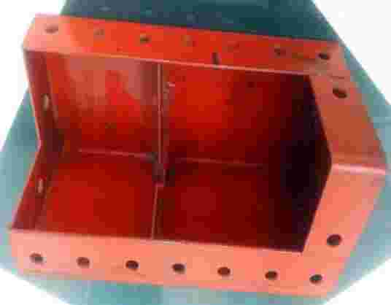

**TSX Trusted Name In China**

**Web:** [www.tsxgroupe.com](http://www.tsxgroupe.com/) **Tel:** +86 68571101 **Fax:** +86 68571102 **Email:** [mike@tsxgroupe.com](mailto:sales@tsxgroupe.com)

:

SS-Trusted Name in CHINA

**Web:** [www.tjtsxgroupe.com](http://www.tjtsxgroupe.com/) **Tel:** +86 13352035283 **Fax:** +86 22 83973368 **Email:** <anna@shishenggroup.com>



**Form Work Accessories**



**Pin**

Stub Thickness: 4.00 – 8.00 mm

Length: 40.00 – 200.00 mm

Surface: Galvanized / Gold Color Galvanized

Materials: Q235 / 20#

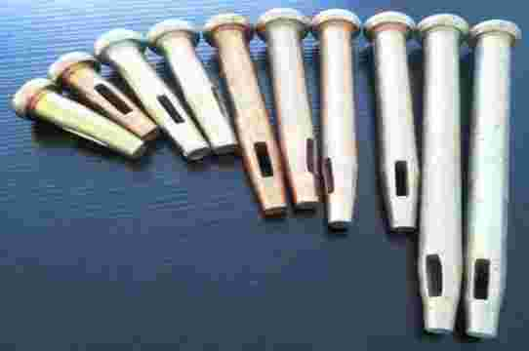

Wedge

Thickness Plate: 2.50 / 2.75 / 3.00 mm

Length: 70.00 / 80.00 mm

Surface: Galvanized / Gold Color Galvanized

Materials: Q235 / 20#

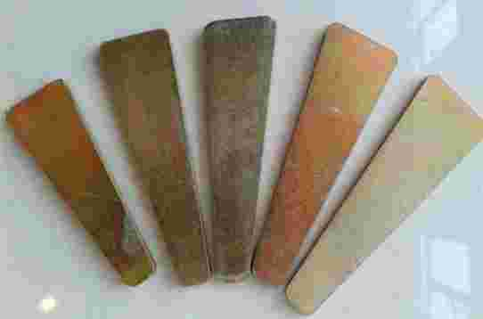

**SS Trusted Name In China**

**Web:** [www.tjtsxgroupe.com](http://www.tjtsxgroupe.com/) **Tel:** +86 13352035283 **Fax:** +86 22 83973368 **Email:** <anna@shishenggroup.com>

:

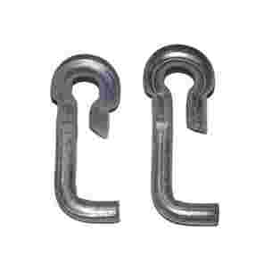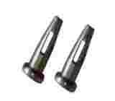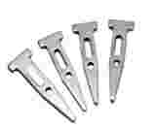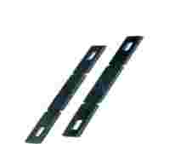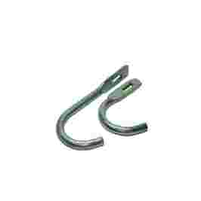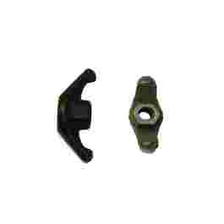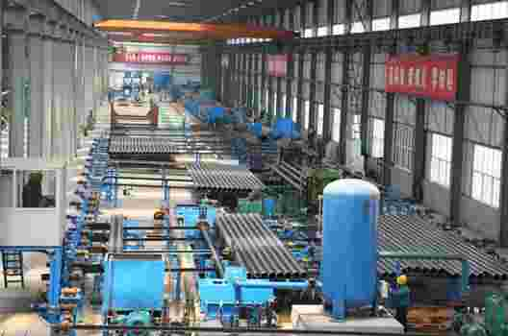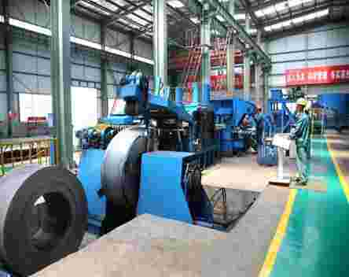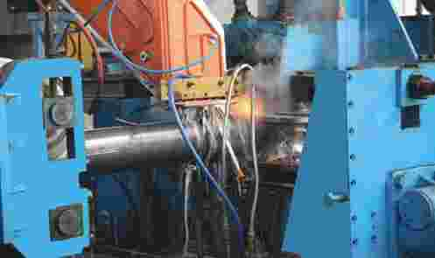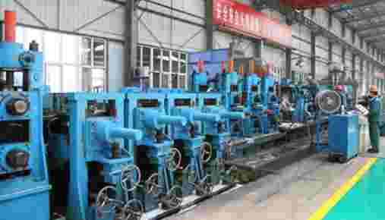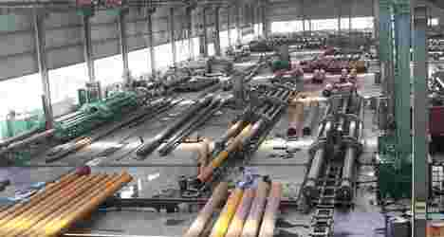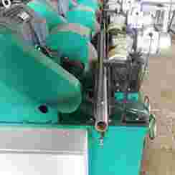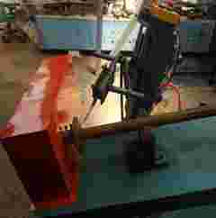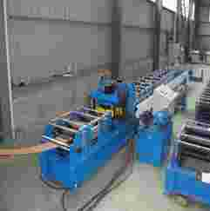

**SS Trusted Name In China**

**Web:** [www.tjtsxgroupe.com](http://www.tjtsxgroupe.com/) **Tel:** +86 13352035283 **Fax:** +86 22 83973368 **Email:** <anna@shishenggroup.com>

:



# Contact us



**SS Groupe - China**

Room 207, FN Building, Hi Tek Information Plaza, NO. 8 Huatian Road, Huayuan Industrial District, 300110 Tianjin, China

**Corporate Phone:**+86 13352035283

**Corporate Fax:**  +86 (22) 83973368

**Email: [anna@shishenggroup.com](mailto:mike@tjtsxgroupe.com)**

**Website:** [http://.shishenggroup.en.alibaba.com](http://www.tjtsxgroupe.com/)/

**Skype**:  **anna1992077**

**SS Trusted Name In China**

**Web:** [www.tjtsxgroupe.com](http://www.tjtsxgroupe.com/) **Tel:** +86 13352035283 **Fax:** +86 22 83973368 **Email:** <anna@shishenggroup.com>

:

